MPLAB® Code Configurator

The MPLAB® Code Configurator generates seamless, easy to understand C code that is inserted into your project. It enables, configures and utilizes a rich set of peripherals across select list of devices. It is integrated into MPLAB® X IDE to provide a very powerful and extremely easy to use development platform.

<http://www.microchip.com/pagehandler/en_us/devtools/code_configurator/home.html>

MPLAB® Code Configurator Plugin  
is available in the MPLAB® X IDE

**MPLAB® Code Configurator Features**

* **Faster Time to Market**
  + Leverage drivers and graphical user interface to reduce development time.
* **Simple, clearly documented driver APIs** in the form of code that can be easily modified and debugged.
* **Reliable, Small Footprint and Efficient**
  + Generated code is reliable and designed for efficient use of CPU and memory resources.
* Email suggestions and observations for MPLAB® Code Configurator

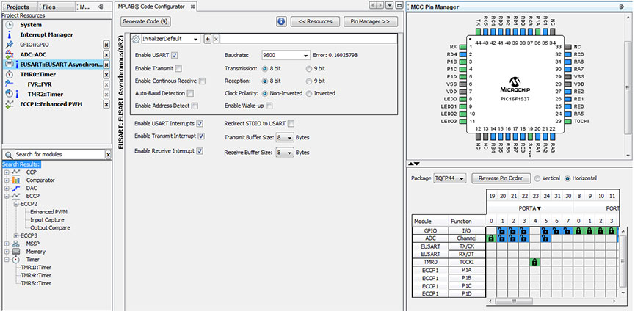

### [Easy to install MPLAB® X IDE Plugin](http://www.microchip.com/pagehandler/en_us/devtools/code_configurator/home.html)

[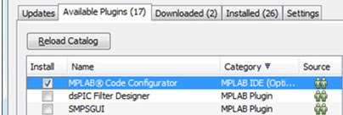](http://www.microchip.com/_images/code_configurator/fig1a.jpg)

All plug-ins are free, available and ready to install once the MPLAB® X IDE has been installed. Just follow the simple steps below to not only see all the available plug-ins but to install the MPLAB® Code Configurator.

1. Select the 'Tools' menu, and click on 'Plugins'
2. In the MPLAB® X IDE Plugins window, click the 'Available Plugins' tab
3. Select MPLAB® Code Configurator and click 'Install'

### [Provides a list of available peripherals](http://www.microchip.com/pagehandler/en_us/devtools/code_configurator/home.html)

[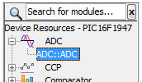](http://www.microchip.com/_images/code_configurator/fig1.jpg)

[+ Click image to enlarge](http://www.microchip.com/_images/code_configurator/fig1.jpg)

The graphical user interface displays all of the available peripherals for the device in the Device Resource area. Simply click on the peripheral you want to add to the project. The peripheral moves to the MCC Project Resources area, and is ready to be configured to your project's requirements.

### [Easily select the peripheral to configure](http://www.microchip.com/pagehandler/en_us/devtools/code_configurator/home.html)

[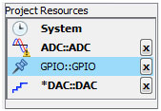](http://www.microchip.com/_images/code_configurator/fig2.jpg)

The MPLAB® Code Configurator Project Resource area displays all of the peripherals currently configured for the project. By selecting a peripheral here, the peripheral is ready to be configured in the Composer area.

In the Project Resource area, the System module is always present. The System module simplifies the setting of Configuration Bits, and configuring the system clock.

### [Integrate MPLAB® Code Configurator code into your existing project, or start a new project from scratch](http://www.microchip.com/pagehandler/en_us/devtools/code_configurator/home.html)

[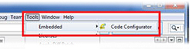](http://www.microchip.com/_images/code_configurator/fig3.jpg)

Using MPLAB® Code Configurator you can add code for a peripheral to your existing project, or you can use MPLAB® Code Configurator to get you started on a new project. If MPLAB® Code Configurator detects a main.c file already in the project, it will not create one. You only need to add two lines to your main.c file to start using the generated drivers. If your project does not have a main.c, MPLAB® Code Configurator will create one for you.

### [Integrated with MPLAB® X IDE](http://www.microchip.com/pagehandler/en_us/devtools/code_configurator/home.html)

[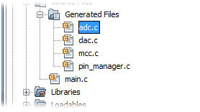](http://www.microchip.com/_images/code_configurator/fig4.jpg)

The code generated by MPLAB® Code Configurator is automatically added to your project. When a peripheral is added to MPLAB® Code Configurator and the generated code, the new files and code are automatically added to the project. All of the MPLAB® X IDE features work with code generated by MPLAB® Code Configurator , like auto-completion, and code navigation.

### [Quickly set configuration bits](http://www.microchip.com/pagehandler/en_us/devtools/code_configurator/home.html)

[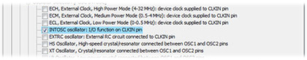](http://www.microchip.com/_images/code_configurator/fig5.jpg)

The System Clock and Configuration Bits can be quickly configured in the Composer area. The system clock rate configured here, will automatically be used by MPLAB® Code Configurator to calculate timer periods, duty cycles, and baud rates as required by other peripherals.

### [Generates standardized driver code](http://www.microchip.com/pagehandler/en_us/devtools/code_configurator/home.html)

[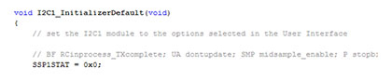](http://www.microchip.com/_images/code_configurator/fig6.jpg)

[+ Click image to enlarge](http://www.microchip.com/_images/code_configurator/fig6.jpg)

MPLAB® Code Configurator generates custom standardized driver code based on the selections made in the Composer area. This is real code that is automatically added to your project. The code can be debugged, edited, and reviewed, just like any other code. It can be modified manually, or reconfigured in the MPLAB® Code Configurator Composer window and

### [Simple to Remove peripherals](http://www.microchip.com/pagehandler/en_us/devtools/code_configurator/home.html)

[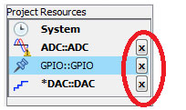](http://www.microchip.com/_images/code_configurator/fig7.jpg)

[+ Click image to enlarge](http://www.microchip.com/_images/code_configurator/fig7.jpg)

Removing a peripheral is simple. Any device in the Project resource area can be removed from the project by clicking on the X to the right of the peripheral.

### [Retain your changes to generated code](http://www.microchip.com/pagehandler/en_us/devtools/code_configurator/home.html)

[Retain your changes to generated code](http://www.microchip.com/_images/code_configurator/fig8.jpg)

Code generated by MPLAB® Code Configurator can be edited like any other code. The generated code is real code! If you choose to modify the code after it is generated you are free to do so. But what happens if you also change the configuration in MPLAB® Code Configurator and generate the code again? No problem. MPLAB® Code Configurator detects your changes and displays a comparison window that allows you to select whether to keep your changes, or the newly generated code.

Your code is shown on the left, and the newly generated code is shown on the right. Navigation buttons at the top let you move to each difference found. An arrow along the center margin allows you to copy your changes into the generated code.

### [Easily configured GPIOs](http://www.microchip.com/pagehandler/en_us/devtools/code_configurator/home.html)

[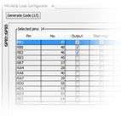](http://www.microchip.com/_images/code_configurator/fig9.jpg)

[+ Click image to enlarge](http://www.microchip.com/_images/code_configurator/fig9.jpg)

Port pins can be configured as GPIO pins simply by clicking on the Pin Manger. Every pin can be given a custom name. That name is then used in the Pin Manger display, and in the generated code.

The direction of a pin, input or output, as well as the starting value, can be configured in a few clicks. For input pins the weak pull-up (WPUE), and the interrupt on change (IOC) can also be configured.

### [Configure the peripheral interrupts used by the system](http://www.microchip.com/pagehandler/en_us/devtools/code_configurator/home.html)

[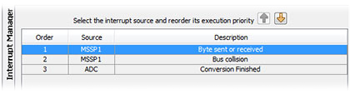](http://www.microchip.com/_images/code_configurator/fig10.jpg)

[+ Click image to enlarge](http://www.microchip.com/_images/code_configurator/fig10.jpg)

Easily change the order in which interrupt service routines are called in the Interrupt Manager. Select a peripheral interrupt and click on the up or down arrow to set the execution priority.

### [Configure pins used by peripherals](http://www.microchip.com/pagehandler/en_us/devtools/code_configurator/home.html)

[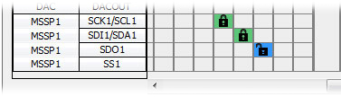](http://www.microchip.com/_images/code_configurator/fig11.jpg)

When a peripheral is added to the Project Resources area, the pins associated with the peripheral are displayed in the Pin Manager. Clicking on a pin in the Pin Manger locks that pin to the selected peripheral.

### [Package view of the pin configuration](http://www.microchip.com/pagehandler/en_us/devtools/code_configurator/home.html)

[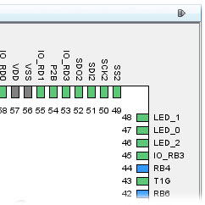](http://www.microchip.com/_images/code_configurator/fig12.jpg)

The Pin Manger includes a package view of the device showing the configuration of the pins. When pins are assigned custom names in MPLAB® Code Configurator, the package view display the custom name. The package view can be copied and printed for use in other documentation.

### [Generate and use specialized drivers](http://www.microchip.com/pagehandler/en_us/devtools/code_configurator/home.html)

[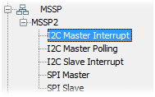](http://www.microchip.com/_images/code_configurator/fig13.jpg)

Specialized peripheral drivers focus on specific functions of a peripheral. For example the MSSP can be used for I2C or SPI. Both of those functions can be used a Master or a Slave. The MPLAB® Code Configurator provides specialized drivers to let you focus on the desired function of a peripheral instead of requiring you to configure the individual control registers.

Per rimappare I pin la questione è grafica.

