From Instance to the Multiple instance

On 15.07.2017, at the headquarters of G-Tronic, in Via Austria 19 in Padua we developed a program to better understand how to create and use functional blocks: the program goal was to make the sum of two different pairs of summands when the E124.0 contact closes.

In the tested procedure we saw that for each operation we need a corresponding DB. In other words if we want to execute through the same FB1 ("Sum") multiple additions we must associate each of them with a different instance DB. To reduce the number of data blocks (which, using this procedure, would be as many as the instances), multiple instance should be used.

In order to better understand what is a multiple instance , in these pages, we propose what we did at the G-tronic headquarters in Padua on 22.7.2017.

Starting with the project that makes the sum of two different instances we first have to:

- create a new superordinate FB (in our example the FB10).

- call the FB1 as a "local instance".

Let's see how to do it.

1. Right-click inside the block folder and insert a new functional block on which the multiplication property is active.





1. between the static FB10 variables define the name of a new variable. In the data type column select FB1 or "Sum". We have to do this for each call of the FB1, and so for each instance associated with the functional block FB1.

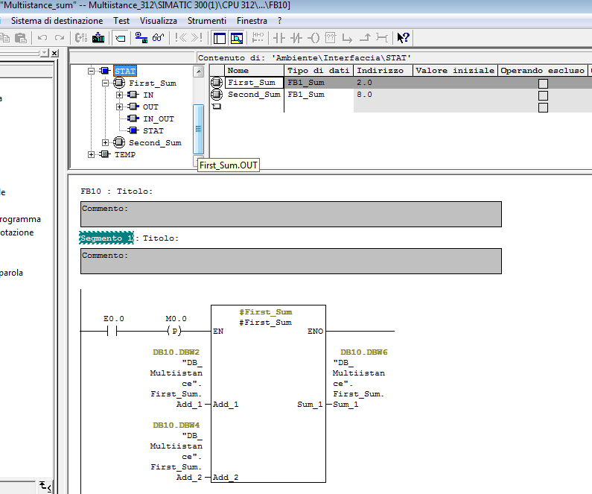

In order to enter the "Somma" function block as the data type, once the name of the static variables (in our case "First_Sum" and "Second_sum") is defined, open the "Data Type" column and select "FB <Nr> "and replace <nr> with the FB number in our case 1.

Look at the next photo.

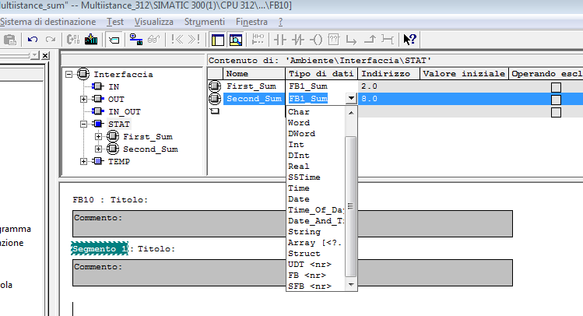

N.B: at this point the declared local instances (First_Sum and Second_Sum) appear in the element catalog

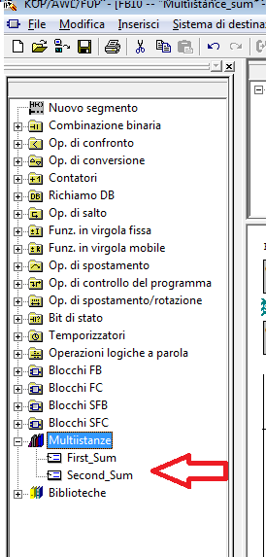

Now insert two segments in the functional block FB10 and drag to each of them the local instances.

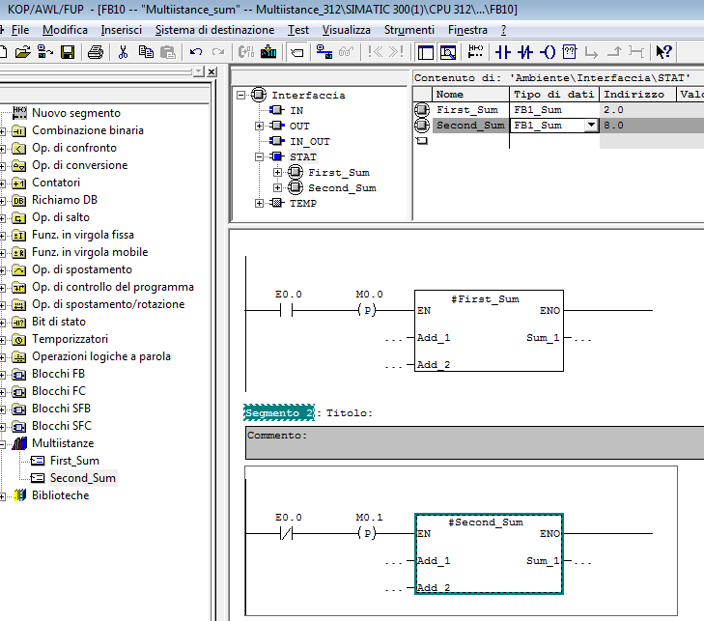

Now what will happen is that for every call the subordinate FB1 will deposit its data into the data block of the superordinate FB10 (DB10). Therefore no DB should be assigned to FB1. All FBs refer to the same data block (here the DB10)

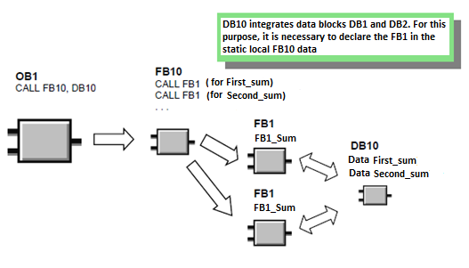

We must then create a data block (DB10) as the FB10 instance block. Let's see how to do it.

1. press right button and choose “Insert a new object”, then “Data Block”.

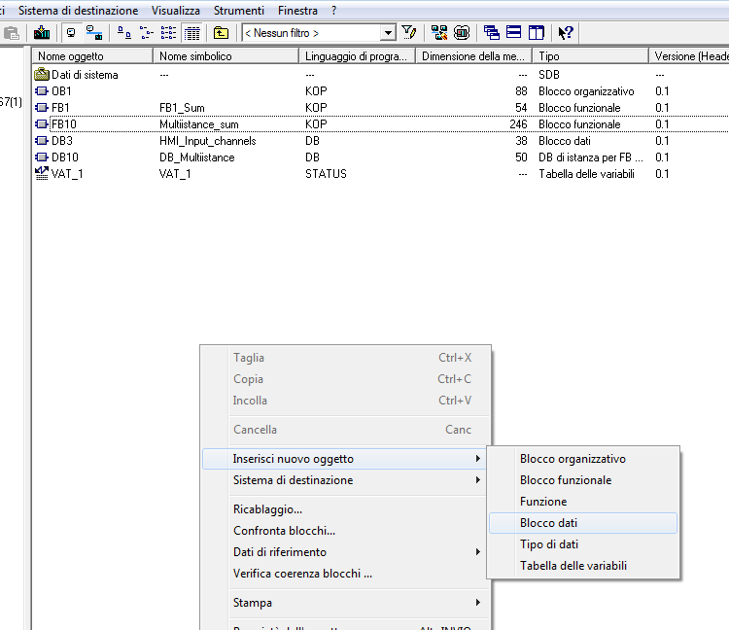

1. In the "Properties - Data Block" dialog box, change the name of the data block to DB10 and in the list box select "Instance DB". Choose "FB10" as assigned function block and confirm all settings with OK. The DB10 data block is added.

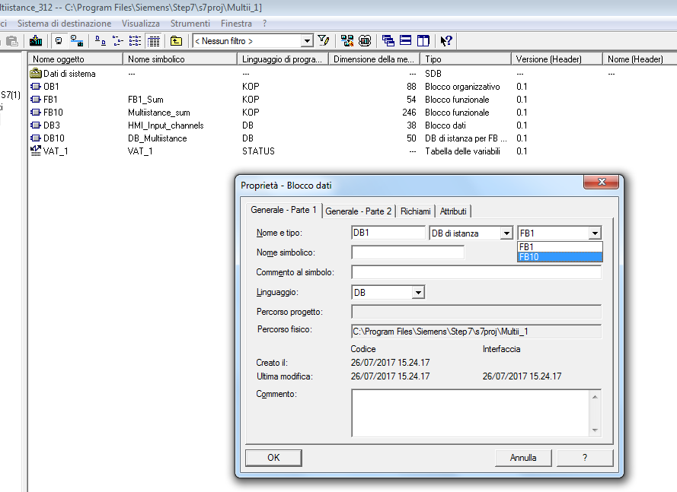

1. open the DB10 with a double click. To parameterize the instance data block click YES in the displayed dialog box.

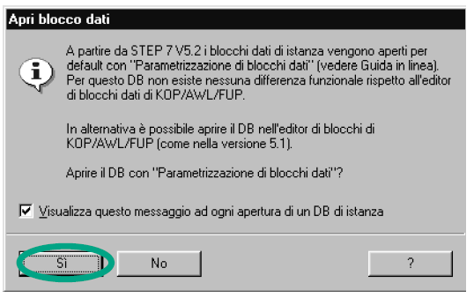

All variables are now contained in the DB10 variable declaration table. In the first part of the table you’ll see the variables for the "First_Sum" functional block and at the bottom the variables for the "Second_Sum" functional block.

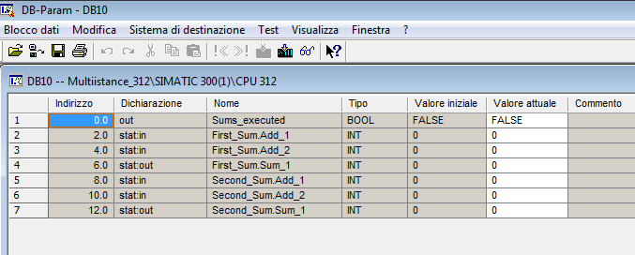

The last thing to do now is to call the FB10 block in OB1.

- Open the OB1 and then use Tools> Symbol Table to open the Symbol Table. Enter, if necessary, in the symbol table, the symbolic names for the FB10 function block and the DB10 data block. Finally, save the symbol table and close the window

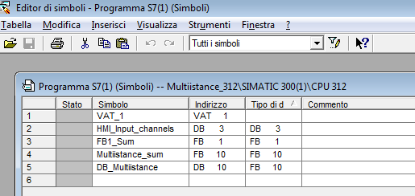

In OB1 now we insert a new segment and we complete it by inserting the FB10 ("Multiinstance_sum") on the same segment. Then:

- Delete the FB1 call in OB1 (segments 1 and 2): FB1 is now called via FB10. Finally, save the program and close the block.

- Delete the instance DBs (DB1 and DB2) to which FB1 was referenced because now, as written before, for each call "the subordinate FB1 deposits its data into the DB10 data block of the superordinate FB10.

Any DB must not be assigned now to FB1. All FBs refer to a single data block (here the DB10). "

GVCF